Screenshots-

1. Homepage-

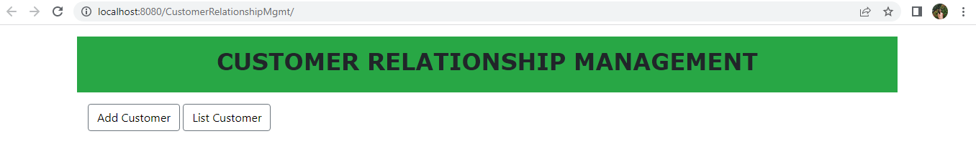

1. List Customer-

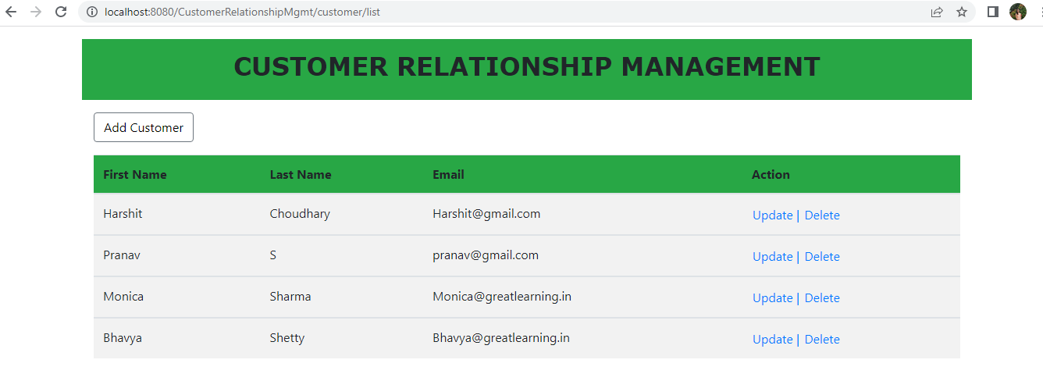

1. Add Customer – Also have **Back to List** link at the end of form

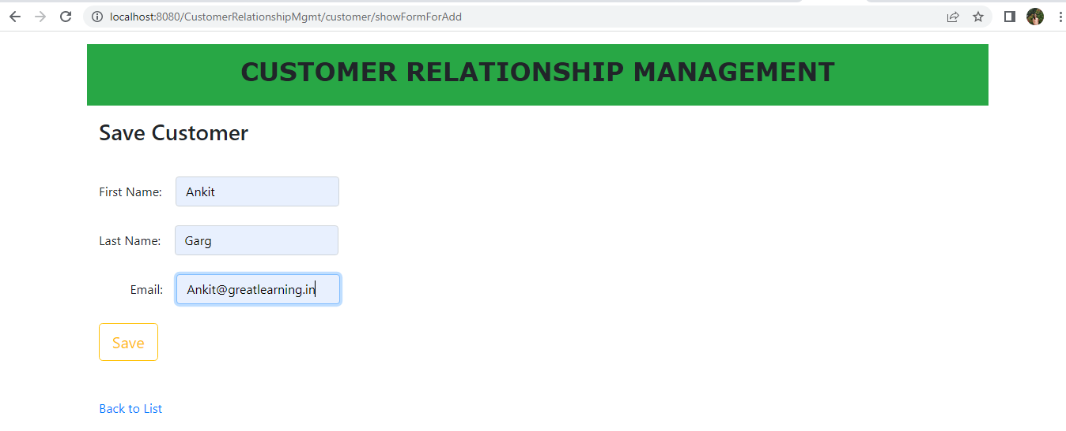

1. Save Customer – after clicking on Save showing list of customers

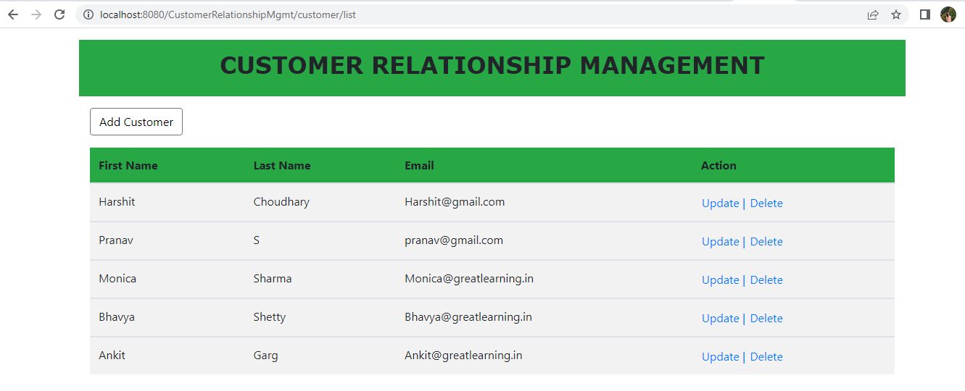

1. Update Customer – updating Ankit Garg email id to AnkitGarg@greatlearning.in

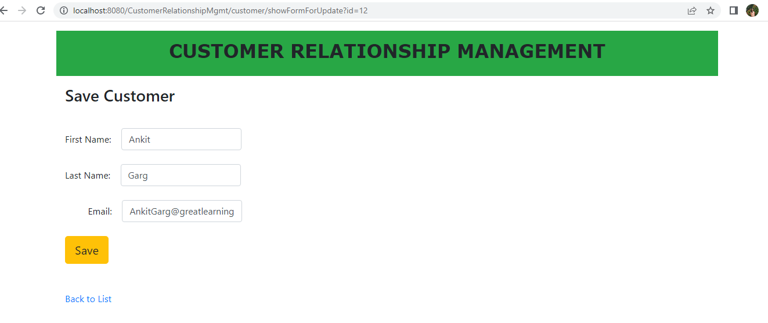

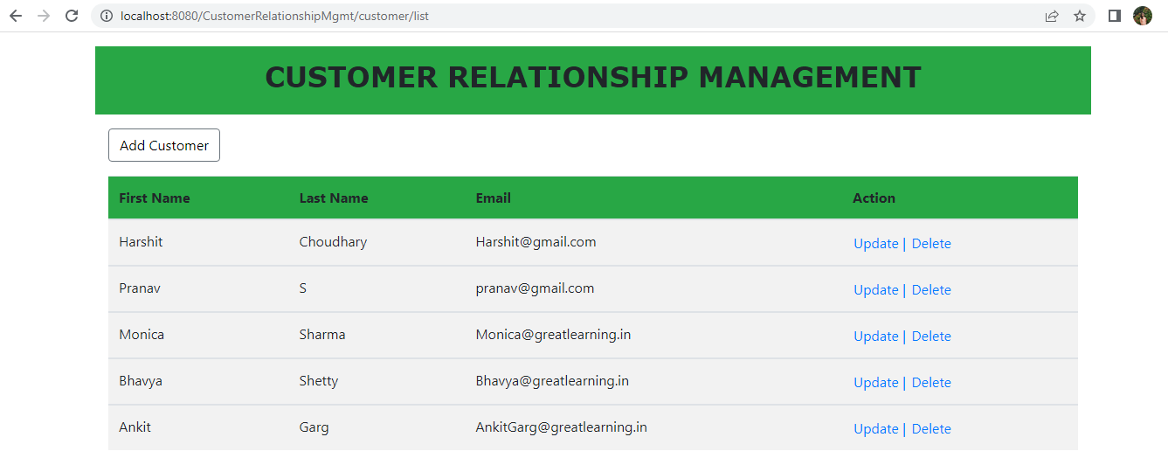

1. Delete Customer –

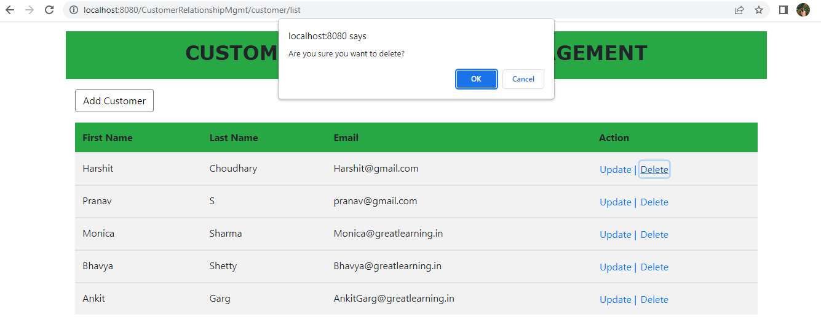

After deleting Harshit Choudhary cutomer, list of customers-

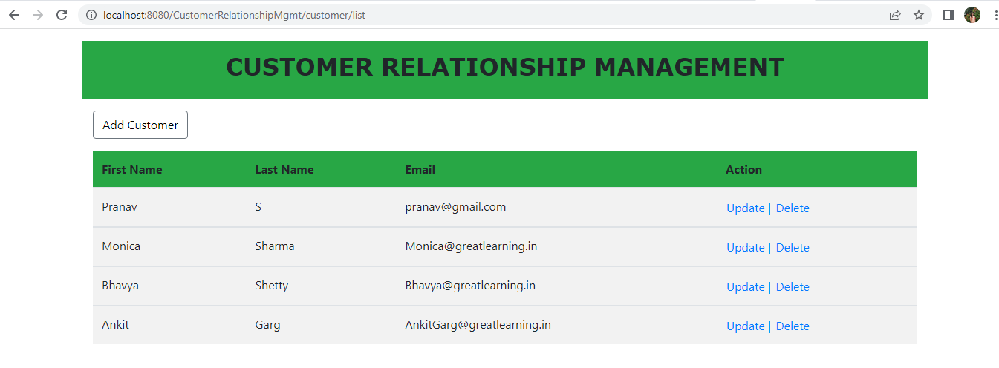

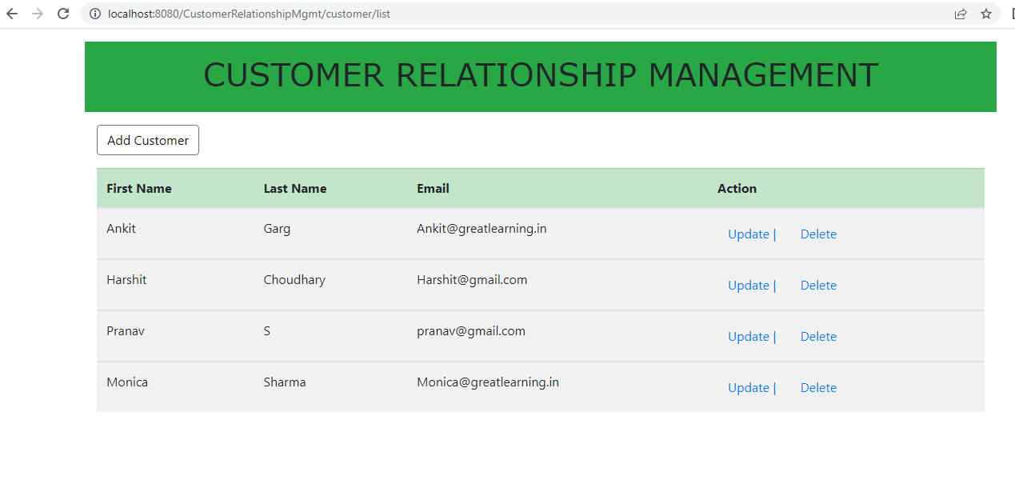

1. Add

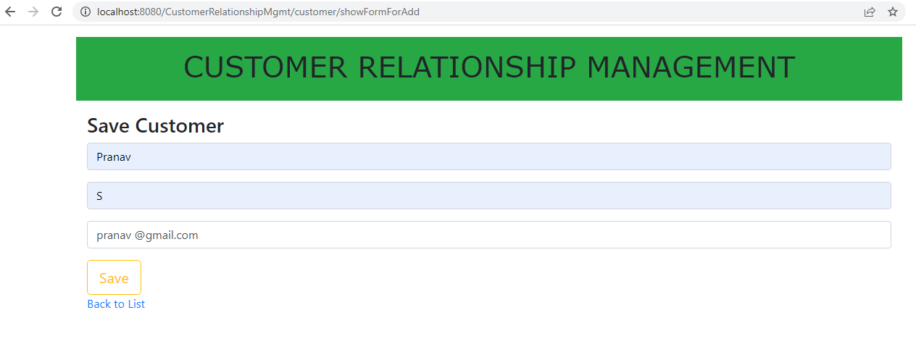

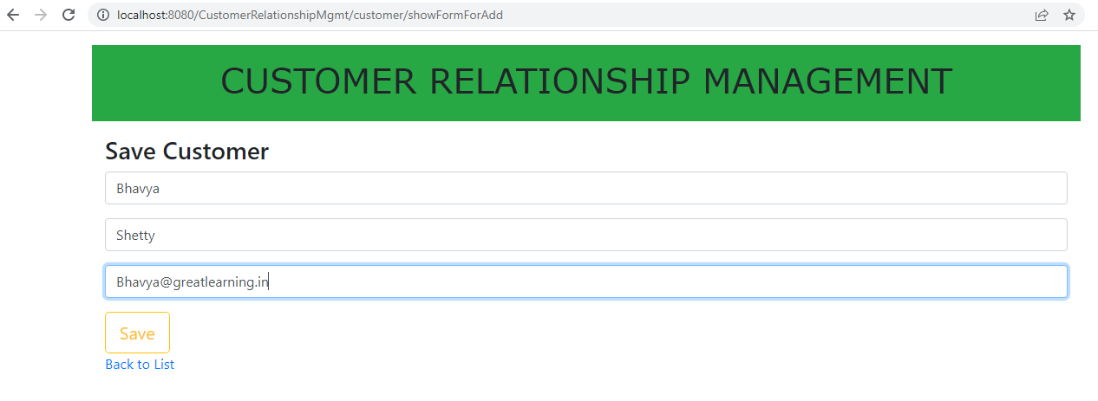

List after addition –

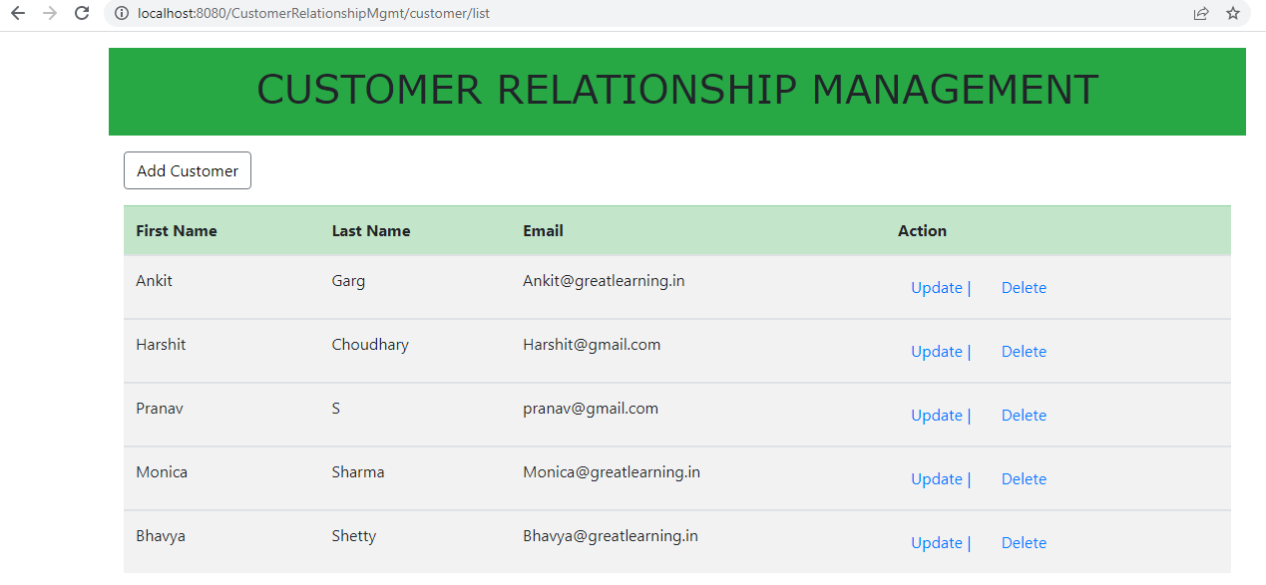

"if(!(confirm('Are you sure you want to delete this customer')))"

1. Update

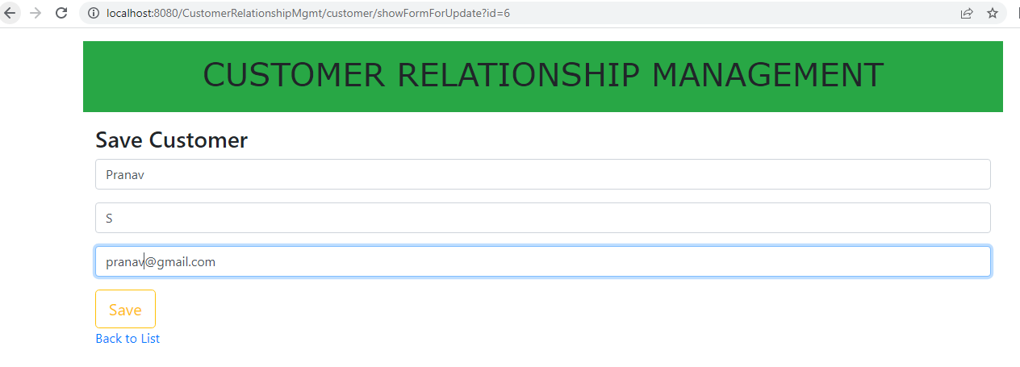

1. Delete